Lab 9 Generating MIPS CODE

Yuhao Lan

Levels:

a)  Can only read and write variables and numbers 40% off

b)  A program which calls no functions and does no array arithmetic at least 30% off

c)  Can do a-b and "if" and "while"  20% off

d)  Can do a-c and also arrays   10%

e)  Can do a-d and handle function calls

f)  Add strings to "write", Extra Credit 5%... You MUST do a-e do get the extra credit

I have finished a) b) c) and part of e). So I think I will get 85% of the whole scores.

TEST ONE:

void main (int b)

{

read b;

if (b > 10)

write 1;

else

write 0;

}

the output:

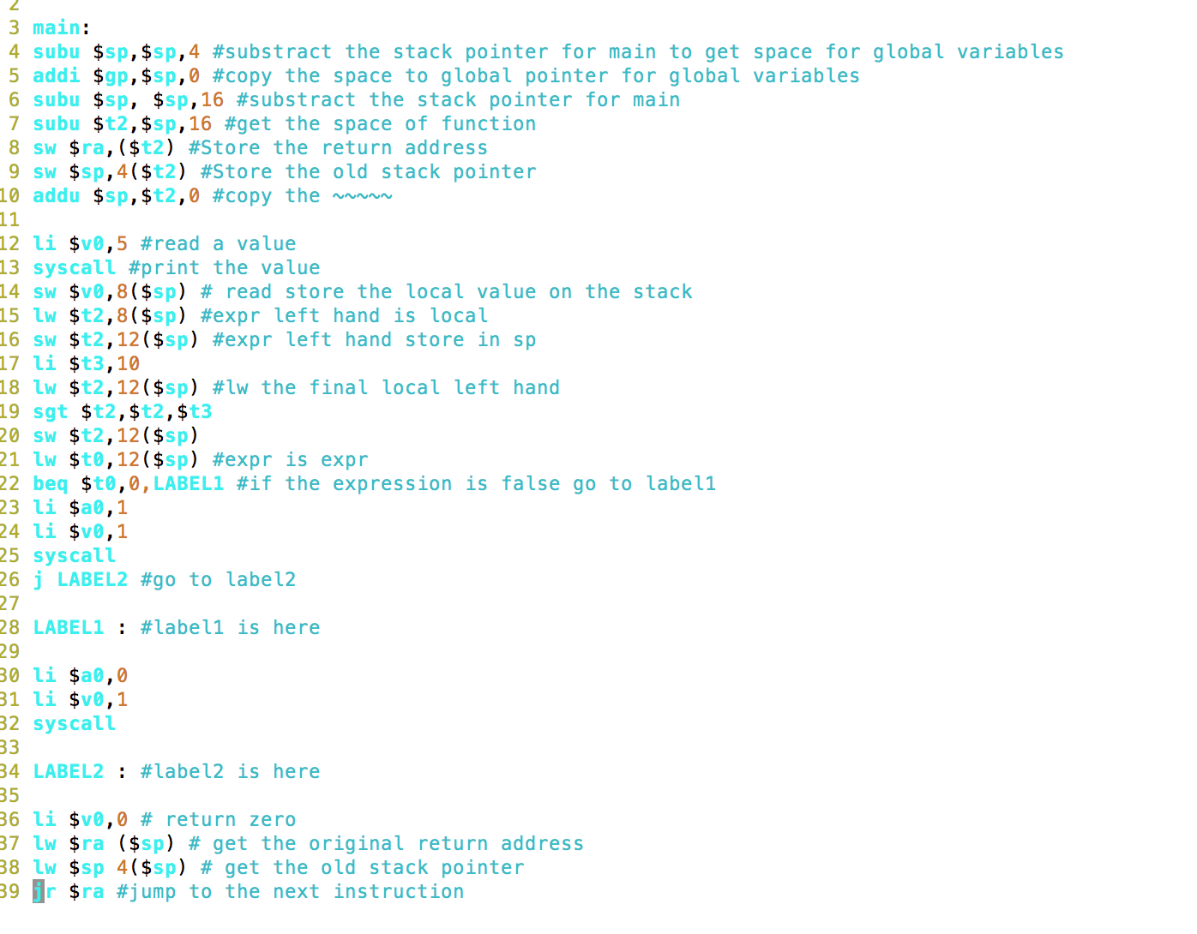

MIPS OUTPUT:

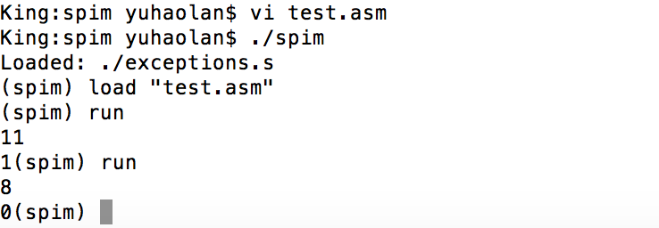

TEST TWO:

int x;

int main(int b)

{ int y;

int sum;

sum=0;

x=1;

read y;

while (x <= y)

{

sum= sum + x;

write x;

x= x+1;

}

write sum;

}

the output:

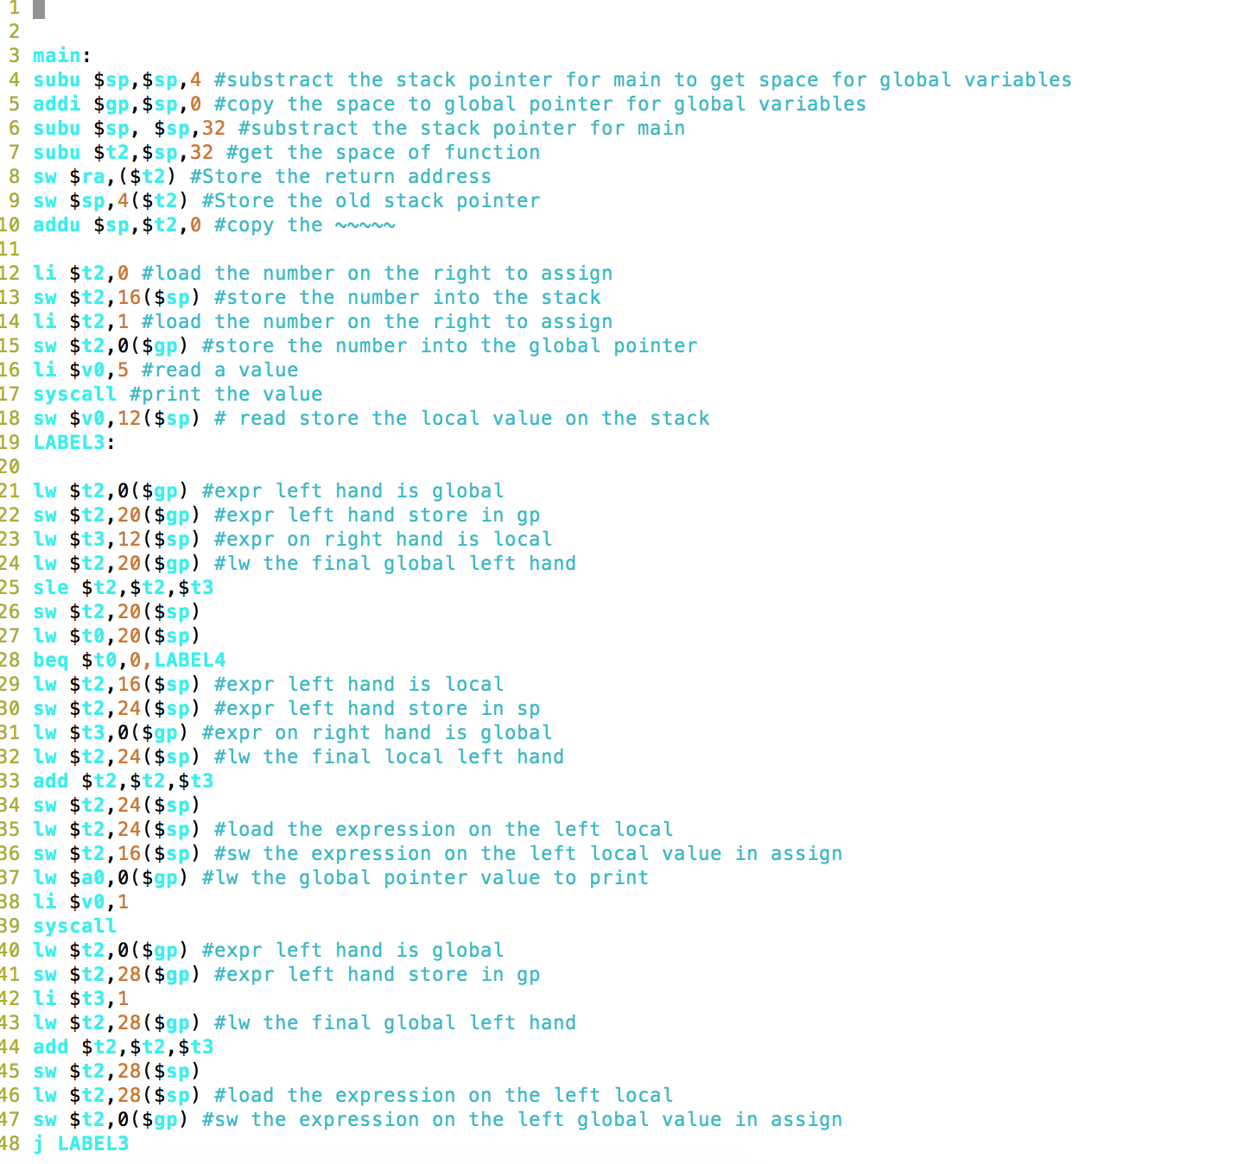

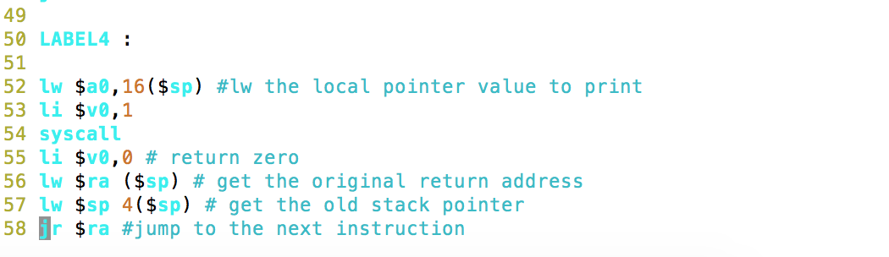

MIPS OUTPUT:

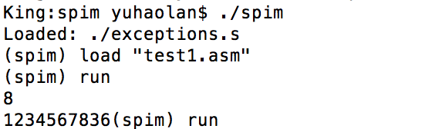

TEST THREE:

int y;

void main(void)

{ int x;

write 5;

read x;

write x;

read y;

write x+y;

}

The MIPS CODE:

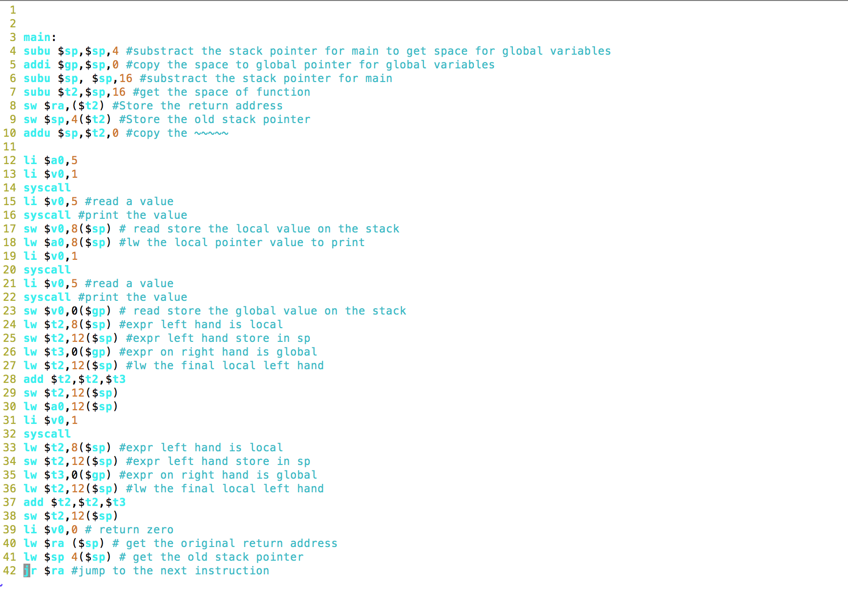

MIPS OUTPUT:

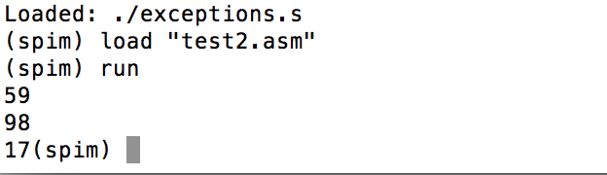

EMIT.C:

#ifndef SYMTABLE

#define SYMTABLE

#include "symbol.h"

#endif

#ifndef AST

#define AST

#include "AST.h"

#endif

void AssignFormals(ASTnode *p, ASTnode *q,int foffset,FILE* fp)

{

if(p==NULL && q==NULL)

{

return ;

} //If both are null then it means its a VOID and a 1 is returned.

else

{

//Switch case is used to be able to assign if value passed is either a number,identifier, expression or a function call

switch(p->right->type)

{

case NUMBER:

printf("a");

fprintf(fp, "li $t2 %d#For a scalar\n",p->right->value);

break;

case IDENT :

printf("a1");

emitASTprint(p->right,fp);

fprintf(fp, "lw $t2 %d($sp)#Assign the word in memory to t2 \n",p->right->symbol->offset*4);

break;

case EXPR:

printf("a2");

emitASTprint(p->right,fp);

fprintf(fp, "lw $t2 %d($sp)#Assign the word in memory to t2(for expr)\n",p->right->symbol->offset*4);

break;

case CALL:

printf("a3");

emitASTprint(p->right,fp);

fprintf(fp, "addu $t2 $v0 0# Assign the return value to t2\n");

break;

}

}

fprintf(fp, "subu $t3 $sp %d #Change the stack pointer and assign it to t3\n",foffset*4);

fprintf(fp, "sw $t2 %d($t3)#Store the t2 value in the stack\n",q->symbol->offset*4);

AssignFormals(p->right,q->left,foffset,fp); //Make a recursive call to assign all actuals to formals

}

//void emit(FILE* fp,char* s,char* command,char* comment)

void emit_header(FILE *fp, int offset, int maxoffset)

{

// update the gp and sp so that we can call main with global variable

printf("##!!@@@the offset in main is %d!!!!\n",offset);

fprintf(fp,"subu $sp,$sp,%d #substract the stack pointer for main to get space for global variables\n",(offset+1)*4);//!!!!

fprintf(fp,"addi $gp,$sp,0 #copy the space to global pointer for global variables\n");

fprintf(fp,"subu $sp, $sp,%d #substract the stack pointer for main\n",maxoffset*4);//!!!!!

}

void emit_func_start(ASTnode *p, FILE* fp)

{

char s[100];

sprintf(s,"%s:\n",p->name);

fprintf(fp,"\n");

fprintf(fp,"\n");

fprintf(fp,"%s",s);

if(strcmp(p->name, "main")==0)

{

emit_header(fp, p->symbol->offset, p->value);

}

//!! move the sp to the function sub sp p->value

fprintf(fp,"subu $t2,$sp,%d #get the space of function\n",p->value*4);

fprintf(fp,"sw $ra,($t2) #Store the return address\n");

fprintf(fp,"sw $sp,4($t2) #Store the old stack pointer\n");

fprintf(fp,"addu $sp,$t2,0 #copy the ~~~~~\n");

fprintf(fp,"\n");

}

void emit_func_return(ASTnode *p, FILE *fp)

{

char s[100];

if(p == NULL || p->right == NULL)

{

fprintf(fp,"li $v0,0 # return zero \n");

}

else

{

switch(p->right->type)

{

case NUMBER:

fprintf(fp,"li $v0,%d\n", p->right->value);

break;

case IDENT:

emitASTprint(p->right, fp);

fprintf(fp,"lw $v0,%d($sp)\n", (p->right->symbol->offset)*4);

//fprintf(fp,"lw $v0,($t2) #load $t2 into $a0 for write\n");

//fprintf(fp, "add $v0,$t0, $zero #return with $v1\n");

break;

case EXPR:

emitASTprint(p->right,fp);

fprintf(fp,"lw $v0,%d($sp)\n", (p->right->symbol->offset)*4);

//fprintf(fp,"add $v0,$t0,$zero #return with $v1\n");

break;

}

}

fprintf(fp,"lw $ra ($sp) # get the original return address\n");

fprintf(fp,"lw $sp 4($sp) # get the old stack pointer\n");

fprintf(fp,"jr $ra #jump to the next instruction\n");

}

//lw $ra ($sp)

//###########################################//###########################################//###########################################

//###########################################//###########################################//###########################################

//###########################################//###########################################//###########################################

void emitASTprint(ASTnode *p, FILE *fp)// what is level

{

int i;

int ii;

char * CreateTemp()

{

char hold[100];

char *label;

sprintf(hold,"LABEL%d",GTEMP++);

label=strdup(hold);

return (label);

}

//FILE * fp;

//fp = fopen ("MIPS.txt", "w+");

if (p == NULL ) return;

else

{

switch (p->type)

{

//declaration

case VARDEC :

printf("Variable ");

switch(p->operator)

{

case INTDEC : printf("INT");break;

case VOIDDEC : printf("VOID");break;

}

printf(" %s",p->name);

if (p->value > 0)

{

printf("[%d]",p->value);

}

printf("\n");

break;

//**************************************FUNCTION*************************************************

//**************************************FUNCTION*************************************************

//**************************************FUNCTION*************************************************

case FUNCTIONDEC :

/*

subu $sp, $sp, NUM # number of bytes we need for the global data segment

addi $gp, $sp, 0 # update the global pointer

subu $sp, $sp, NUM1 # the number of bytes needed for main to run

NUM is the global offset of all entities declared at the global level.

NUM1 is the # of bytes main needs for its runtime stack

*/

emit_func_start(p,fp);//p->s1 is about param p->right is about compoundstmt

emitASTprint(p->right,fp);//print the compound statement

emit_func_return(NULL,fp);

break;

//**************************************END-FUNCTION*************************************************

//**************************************END-FUNCTION*************************************************

//**************************************END-FUNCTION*************************************************

case BLOCK :

printf("BLOCK STATEMENT\n");

emitASTprint(p->right,fp);

break;

case PARAMEXPR :

printf("PARAMETER ");

switch(p->operator)

{

case INTDEC : printf("INT");break;

case VOIDDEC : printf("VOID");break;

}

printf(" %s\n",p->name);

if (p->value > 0)

printf("[%d]",p->value);

break;

//assignment statement

case ASSIGN :

//WRONG!!!

printf(" ASSIGNMENT STATMENT!!!!!!\n");

emitASTprint(p->right,fp);//VAR==IDENT

// printf("I AM HERE %d !!!!!!\n",++ii);

//emitASTprint(p->s1,fp);//

// printf("I AM HERE %d !!!!!!\n",++ii);

//assignmentstmt : var '=' expressionstmt : p->right is var p->s1 is expr

switch(p->s1->right->type)

{

case NUMBER :

// printf("I AM HERE ~~~~num %d !!!!!!\n",++ii);

fprintf(fp,"li $t2,%d #load the number on the right to assign\n",p->s1->right->value);

if(p->right->symbol->level == 0)

{

fprintf(fp,"sw $t2,%d($gp) #store the number into the global pointer\n",p->right->symbol->offset*4);

}

else

{

fprintf(fp,"sw $t2,%d($sp) #store the number into the stack\n",p->right->symbol->offset*4);

}

break;

case IDENT :

//printf("I AM HERE ~~~~ident %d !!!!!!\n",++ii);

if(p->right->symbol->level == 0)//check the VAR

{

fprintf(fp,"sw $t2,%d($gp) #sw the global value on the left in assign\n",p->right->symbol->offset*4);

}

else

{

fprintf(fp,"sw $t2,%d($sp) #sw the local value on the left in assign\n",p->right->symbol->offset*4);

}

if (p->s1->right->symbol->level == 0)//check the expr

{

fprintf(fp,"lw $t2,%d($gp) #lw the global value on the right in assign\n",p->s1->right->symbol->offset*4);

}

else

{

fprintf(fp,"lw $t2,%d($sp) #lw the local value on the right in assign\n",p->s1->right->symbol->offset*4);

}

break;

case EXPR :

// printf("I AM HERE ~~~~~expr %d !!!!!!\n",++ii);

emitASTprint(p->s1,fp);

fprintf(fp,"lw $t2,%d($sp) #load the expression on the left local\n",p->s1->right->symbol->offset*4);

if(p->right->symbol->level == 0)

{

fprintf(fp,"sw $t2,%d($gp) #sw the expression on the left global value in assign \n",p->right->symbol->offset*4);

}

else

{

fprintf(fp,"sw $t2,%d($sp) #sw the expression on the left local value in assign \n",p->right->symbol->offset*4);

}

break;

}

break;

case IDENT :

printf("IDENTIFIER !!!!%s\n",p->name);

//check the right is null or not

if (p->right != NULL)

{

printf(" Array Reference [\n");

emitASTprint(p->right,fp);

printf(" ] end array\n");

}

break;

case EXPR :

//#####################EMIT FOR EXPR #########################################################

//#####################EMIT FOR EXPR #########################################################

//#####################EMIT FOR EXPR #########################################################

//#####################EMIT FOR EXPR #########################################################

//#####################EMIT FOR EXPR #########################################################

//WRONG!!!!

/*

if (p->s1 == NULL)

{

switch (p->type)

{

case NUMBER :

//store the left hand side value

//QUSTION why need sw???

fprintf(fp,"li $t2,%d\n",p->value);

fprintf(fp, "sw $t2,%d($sp)\n",p->symbol->offset*4);

break;

}

}

*/

//compute the left hand side

switch(p->right->type)

{

case NUMBER :

//store the left hand side value

//QUSTION why need sw???

printf("~~~~~~~~~~~~~~~~~~$t2,%d\n",p->right->value);

fprintf(fp,"li $t2,%d\n",p->right->value);

fprintf(fp, "sw $t2,%d($sp)\n",p->symbol->offset*4);

break;

case IDENT :

// ID can be x or x[100]

if (p->right->symbol->level == 0)

{

fprintf(fp,"lw $t2,%d($gp) #expr left hand is global\n",p->right->symbol->offset*4);

fprintf(fp,"sw $t2,%d($gp) #expr left hand store in gp\n",p->symbol->offset*4); }

else

{

fprintf(fp,"lw $t2,%d($sp) #expr left hand is local\n",p->right->symbol->offset*4);

fprintf(fp,"sw $t2,%d($sp) #expr left hand store in sp\n",p->symbol->offset*4);

}

break;

case EXPR ://wrong QUSTION

emitASTprint(p->right,fp);// QUESTION should it be repeated???????

fprintf(fp,"lw $t2,%d($sp)\n",p->right->symbol->offset*4);//QUESTION why I need this line?????

fprintf(fp,"sw $t2,%d($sp)\n",p->symbol->offset*4);// should it recusivly to call

break;

}

//BOTTOM UP

//compute the right hand side

switch(p->s1->type)

{

case NUMBER :

printf("#################$t3,%d\n",p->s1->value);

fprintf(fp,"li $t3,%d\n",p->s1->value );

break;

case IDENT :

if(p->s1->symbol->level == 0)

{

fprintf(fp,"lw $t3,%d($gp) #expr on right hand is global\n",p->s1->symbol->offset*4);

}

else

{

fprintf(fp,"lw $t3,%d($sp) #expr on right hand is local \n",p->s1->symbol->offset*4);

}

break;

case EXPR :

emitASTprint(p->s1,fp);

fprintf(fp,"lw $t3 %d($sp)\n",p->s1->symbol->offset*4);

// fprintf(fp,"sw $t3 %d($sp)\n",p->symbol->offset*4);// QUESTON why is p->symbol offset??? not p->right

break;

}

if (p->right->symbol->level == 0)

{

fprintf(fp,"lw $t2,%d($gp) #lw the final global left hand\n",p->symbol->offset*4);// should it recusivly to call

}

else

{

fprintf(fp,"lw $t2,%d($sp) #lw the final local left hand\n",p->symbol->offset*4);// should it recusivly to call

}

switch(p->operator)

{

case PLUS :

fprintf(fp,"add $t2,$t2,$t3\n");

fprintf(fp,"sw $t2,%d($sp)\n",p->symbol->offset*4);

break;

case MINUS :

fprintf(fp,"sub $t2,$t2,$t3\n");

fprintf(fp,"sw $t2,%d($sp)\n",p->symbol->offset*4);

break;

//QUESTION should we do times and division?????

case TIMES :

fprintf(fp, "mult $t2,$t3\n");

fprintf(fp, "mflo $t2\n");

fprintf(fp,"sw $t2,%d($sp)\n",p->symbol->offset*4);

break;

case DIVIDE :

fprintf(fp, "div $t2,$t3\n");

fprintf(fp, "mflo $t2\n");

fprintf(fp,"sw $t2,%d($sp)\n",p->symbol->offset*4);

break;

//!!WRONG

case LESSTHANEQUAL :

fprintf(fp,"sle $t2,$t2,$t3\n");

fprintf(fp,"sw $t2,%d($sp)\n",p->symbol->offset*4);

break;

case LESSTHAN :

fprintf(fp,"slt $t2,$t2,$t3\n");

fprintf(fp,"sw $t2,%d($sp)\n",p->symbol->offset*4);

break;

case GREATERTHAN :

fprintf(fp,"sgt $t2,$t2,$t3\n");

fprintf(fp,"sw $t2,%d($sp)\n",p->symbol->offset*4);

break;

case GREATERTHANEQUAL :

fprintf(fp,"sge $t2,$t2,$t3\n");

fprintf(fp,"sw $t2,%d($sp)\n",p->symbol->offset*4);

break;

case EQUAL :

fprintf(fp,"seq $t2,$t2,$t3\n");

fprintf(fp,"sw $t2,%d($sp)\n",p->symbol->offset*4);

break;

case NOTEQUAL :

fprintf(fp,"sne $t2,$t2,$t3\n");

fprintf(fp,"sw $t2,%d($sp)\n",p->symbol->offset*4);

break;

}

//######################################################################################

//######################################################################################

//######################################################################################

//######################################################################################

//#######################END EMIT#######################################################

//######################################################################################

printf(" EXPR");

//emitASTprint(p->right,fp);//additiveexpression

//relop

//emitASTprint(p->s1,fp);//additiveexpression

break;

case NUMBER :

if (p->value >0)

printf("Number with value %d\n",p->value);

break;

case CALL :

printf("I am here 1\n");

AssignFormals(p->right,p->symbol->fparms,p->symbol->offset,fp);//Call AssignFormals to store the actual arguments in the formals location

printf("I am here 2\n");

fprintf(fp,"jal %s #call the function name\n",p->name);

printf("I am here 3\n");

break;

//if statement

case IFSTMT :

//######################IF STMT #######################################################################

//######################IF STMT #######################################################################

//######################IF STMT #######################################################################

//######################IF STMT #######################################################################

printf("IF STATMENT\n");

int ii;

//printf("//######################I am here %d\n",++ii);

//hand the expression

switch (p->right->type)

{

case NUMBER :

fprintf(fp,"li $t0,%d #expr is number\n",p->right->value);

break;

case IDENT :

//!!

if (p->right->symbol->level == 0)

{

fprintf(fp,"lw $t0,%d($gp) #in if the expr is local indent\n",p->right->symbol->offset*4);

}

else

{

fprintf(fp,"lw $t0,%d($sp) #in if the expr is local indent\n",p->right->symbol->offset*4);

}

break;

case EXPR :

emitASTprint(p->right,fp);

fprintf(fp,"lw $t0,%d($sp) #expr is expr\n",p->right->symbol->offset*4);

break;

}

//printf("//######################I am here %d\n",++ii);

char* label1=CreateTemp();

char* label2=CreateTemp();

fprintf(fp,"beq $t0,0,%s #if the expression is false go to label1\n",label1);

//printf("//######################I am here %d\n",++ii);

// if the expression is true we go to S1

emitASTprint(p->s1,fp);

if (p->s2 != NULL)

{

fprintf(fp,"j %s #go to label2\n",label2);

}

//printf("//######################I am here %d\n",++ii);

// if expression is false go to s2

fprintf(fp,"\n%s : #label1 is here\n\n",label1);

emitASTprint(p->s2,fp);

fprintf(fp,"\n%s : #label2 is here\n\n",label2);

break;

//######################END IF#######################################################################

//######################END IF#######################################################################

//######################END IF#######################################################################

//while loop

case WHILEEXPR :

//######################WHILE STMT#######################################################################

//######################WHILE STMT#######################################################################

printf("WHILE STATMENT!!!\n");

char* label3=CreateTemp();//wrong why cannot be in front of printf

fprintf(fp,"\n%s: \n\n",label3);

switch (p->right->type)

{

case NUMBER :

fprintf(fp,"li $t0,%d\n",p->right->value);

break;

case IDENT :

if(p->right->symbol->level == 0)

{

fprintf(fp,"lw $t0,%d($gp) #while expr is global indent\n",p->right->symbol->offset*4);

}

else

{

fprintf(fp,"lw $t0,%d($sp) #while expr is load indent\n",p->right->symbol->offset*4);

}

break;

case EXPR :

emitASTprint(p->right,fp);

fprintf(fp,"lw $t0,%d($sp)\n",p->right->symbol->offset*4);

break;

}

char* label4=CreateTemp();

fprintf(fp,"beq $t0,0,%s\n",label4);

emitASTprint(p->s1,fp);

fprintf(fp,"j %s\n",label3);

fprintf(fp,"\n%s : \n\n",label4);

break;

//######################END WHILE STMT #######################################################################

//######################END WHILE STMT #######################################################################

//return

case RETURNEXPR :

printf("RETURN STATMENT\n");

emitASTprint(p->right,fp);

emit_func_return(p->right,fp);

//emit fun return

break;

//read

case READSTMT :

//QUESTION!!!!!!!

// fprintf(fp,"sub $sp,$sp,%d\n",p->right->symbol->offset*4);//substract the sp size

fprintf(fp,"li $v0,5 #read a value\n");

fprintf(fp,"syscall #print the value\n");

if(p->right->symbol->level == 0)

{

fprintf(fp,"sw $v0,%d($gp) # read store the global value on the stack\n",p->right->symbol->offset*4);

}

else

{

fprintf(fp,"sw $v0,%d($sp) # read store the local value on the stack\n",p->right->symbol->offset*4);

}

printf("READ STATMENT\n");

emitASTprint(p->right,fp);

break;

//write

case WRITESTMT :

switch(p->right->type)//check the type of write right hand

{

case NUMBER :

fprintf(fp,"li $a0,%d\n",p->right->value);

fprintf(fp,"li $v0,1\n");

fprintf(fp,"syscall\n");

break;

case IDENT :

if (p->right->symbol->level == 0)

{

fprintf(fp,"lw $a0,%d($gp) #lw the global pointer value to print\n",p->right->symbol->offset*4);

fprintf(fp,"li $v0,1\n");

fprintf(fp,"syscall\n");

}

else

{

fprintf(fp,"lw $a0,%d($sp) #lw the local pointer value to print\n",p->right->symbol->offset*4);

fprintf(fp,"li $v0,1\n");

fprintf(fp,"syscall\n");

}

break;

case EXPR :

//QUESTION!!!!

emitASTprint(p->right,fp);//QUESTION !!!!!

fprintf(fp,"lw $a0,%d($sp)\n",p->right->symbol->offset*4);

fprintf(fp,"li $v0,1\n");

fprintf(fp,"syscall\n");

break;

}

printf("WRITE STATMENT\n");

emitASTprint(p->right,fp);

break;

case EXPRSTMT :

printf("EXPRISSION STATMENT\n");

emitASTprint(p->right,fp);

break;

case ARGLIST :

printf("ARGLIST\n");

emitASTprint(p->right,fp);

emitASTprint(p->left,fp);

break;

default: printf("unknown type in emitASTprint\n");

}

emitASTprint(p->left,fp);

}

//fclose(fp);

}

//!!

//!!!!

/*dummy main program so I can compile for syntax error independently

main()

{

}

*/